|  |  |
| --- | --- |
|  | Student Name _______________________  **Eastern Goldfields College**  Mathematics Methods Year 11 2018  Assignment Validation – Calculator Free |
| Reading Time: 1 minute  Working Time: 15 minutes | Total Marks: 15 marks |

Question 1 (4 marks)

A straight line passes through points C (2, -5) and D ( -3, 2). Determine the equation of the straight line that is perpendicular to this line and passes through D $C$, expressing your answer in the form $ax+by+c=0$, where $a$, $b$ and $c$ are integers.

Question 2 (4 marks)

For the graph with equation $y=(x+3)(x-5)$ $y=(x+1)(x-3)$, determine the coordinates of

(a) all axes intercepts. (2 marks)

(b) the turning point. (2 marks)

Question 3 (7 marks)

Solve each of the following equations for the variable $x$.

(a) $2\left(1-x\right)+9=3(2x-7)$. (2 marks)

(b) $\frac{x}{2}$ $=1+$ $\frac{2x}{5}$. (2 marks)

(c) $\frac{4}{x}$ $=2+2x$. (3 marks)

|  |  |
| --- | --- |
|  | Student Name _______________________  **Eastern Goldfields College**  Mathematics Methods Year 11 2018  Assignment Validation – Calculator Assumed |
| Reading Time: 2 minutes  Working Time: 20 minutes | Total Marks: 16 marks |

Question 4 (6 marks)

(a) Determine the size, to the nearest degree, of the smallest angle in a triangle with sides of lengths 23 cm, 28 cm and 31 cm. (3 marks)

(b) The area of the triangle shown below is 280 cm2. Determine the value of $x$. (3 marks)

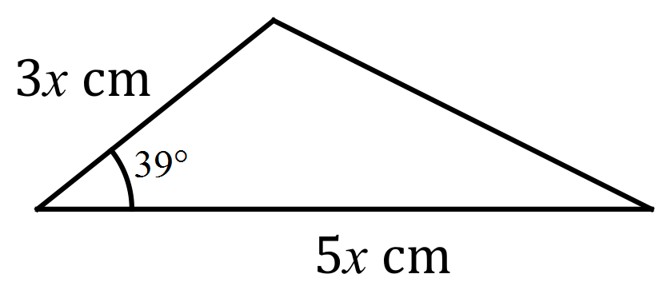

Question 5 (6 marks)

From an analysis of the species of fish caught by 107 anglers during a competition, it was found that 65 anglers had caught tailor, 81 anglers had caught herring and 9 had caught neither of these species.

Let set $T$ be the set of anglers who had caught tailor and set $H$ be the set of anglers who had caught herring.

(a) Use set notation to describe the set of anglers who caught herring but not tailor.

(1 mark)

(b) Determine

(i) $n(H∩T)$. (2 marks)

(ii) $n(\overline{H}∪T)$. (1 mark)

(b) If one angler from the competition is selected at random, determine $P\left(\overline{H} \right| \left(H∪T\right) )$.

(2 marks)

Question 6 (4 marks)

At 3 pm, the length of the shadow of a thin vertical pole standing on level ground is the same as the height of the pole. A while later, the angle of elevation of the sun has decreased by 15° and the length of the shadow has increased by 85 cm. Determine the height of the pole.